**MURANG’A UNIVERSITY OF TECHNOLOGY**



**SCHOOL OF INFORMATION TECHNOLOGY(SCIT)**

**DEPARTMENT OF INFORMATION TECHNOLOGY**

**ONLINE SHOPPING MANAGEMENT SYSTEM**

**AUTHOR NAME: CLAIRE WAMBUI KARANJA**

**REG NO: SC211/1179/2021**

**DATE :12/04/2023**

**YEAR: 2022/2023**

**DECLARATION**

This is my original project and has never been presented before

Name: Signature:

Date:

**SUPERVISOR:**

I the undersigned do hereby certify that this is a true report for the project undertaken by the above named student under my supervision and that it has been submitted to Mount Kenya University with my approval.

**Supervisor’s name:**  **MR. ……………………………………….**

**Signature: …………………………… Date: ……….APRIL 2023**

# DEDICATION

This research project report is dedicated to my beloved self for having an enormous courage in believing that what I do can always make it beyond expectations. I do also dedicate this work to my close friend who offered me great moral support. Most importantly, I dedicate this project everyone out there who is struggling to make ends meet in their daily struggles.

**ACKNOWLEDGEMENTS**

I would like to acknowledge the sellers who allowed me to put their products in my website . I would also like to thank our lecturer for guiding us and showing us what we are supposed to do . I would also like to acknowledge my fellow sabacode team mates their thoughts and ideas in the making of my project really helped me in the system design phase.

**TABLE OF CONTENTS**

Table of Contents

DEDICATION 3

History of Online Shopping 8

domain name 9

dedicated ip address 9

shopping cart software 10

merchant interface 10

product catalog 10

online payment processor 10

shipping costs calculator 10

tax calculation 10

FACT FINDING TECHNIQUES 11

Introduction 19

Coding 19

Application and Database Connection 19

Testing 19

Functional Testing 19

System Testing 20

Unit testing 20

Test Data 20

File Conversion 21

Control 21

**CHAPTER ONE**

INTRODUCTION

Overview of the current system

Students when they want to buy goods and items for their rental houses they have to manually go to the large mukuyu market to different sellers looking for what they want challenge is they might not really find the item they want or it may be too expensive for them to buy . The vendors at times have to bring their goods to the students such as selling them around the hostel and the goods at times end up not being bought because maybe at the moment the student might not have the cash or the student isn’t interested in the thing. This might be disappointing to both the student and the vendor because the student didn’t get what she or he wants to be sold and the vendor didn’t sell anything.

Limitations

1. The vendors don’t sell their goods
2. Its cumbersome because the student has to go to different places to search for what is needed
3. The good might not be there at the moment so it leads to waste of time and energy
4. Goods go unbought.

**1.PROBLEM DEFINITION**

The problem at hand is that when students around Murang’a university want to shop for something they go through the hustle of searching for it like for example you want to buy a pillow or cups you have to go to multiple vendors asking for the prices of these commodities so that after going through them all you finally choose where to buy at times you might find the thing you want to buy is not there so you go back home exhausted and unsatisfied.

Also at times the vendors bring their goods to the students such as selling them in the hostels but attimes the goods aren’t bought so the vendor goes back disappointed . So this online system students will be looking at their items online and then decide whether to buy or not such items include shoes, earings, socks . It’s a local online system that connects the student with the local vendors.

**2.THE PROPOSED SOLUTION**

There will be an online display of goods sold locally and their prices .Goods sold around Mukuyu market, Murang’a towm and Kiharu . Such that students will be logging in to the system and the goods will be displayed in categories for example bathroom utilities such as mops ,brushes ….etc ,clothes such as denims, durags , t-shirts, beddings such as mattress cover, pillows and bedsheets . Food stuffs and kibandas.

**3.PROPOSED PROJECT TITLE**

The project of the title is clearly stated: Murang’a university online shopping management system

**4. Scope of the system**

The online system will be used by students and also people generally who want to buy goods.

OBJECTIVES

The online system will;

1. Offer a platform where the students can check out the goods
2. The goods sold will be displayed on the system
3. The locations and the prices will also be included
4. One can also buy it online

BENEFITS OF THE SYSTEM

1.Easier to access

2. You can order online

3. Don’t have to go around comparing prices looking for something you want you can just check out the different places selling it and buy where you find best

4. It saves on time and energy

**JUSTIFICATION**

When comrades around the university want to move out they usually get the products from mukuyu market . These products include beds, chairs, sufurias, pan, racks, toilet brushes well several places sell the same products and it can be quite tedious to search for the goods from place to place comparing prices and quality of the item they want . The proposed system will ease in the search of products such that the products will be sold online it wll be a local jumia.

The proposed system is worth developing because;

1. It is faster and cheaper
2. Saves on time and energy
3. It is more efficient to work with
4. Saves on money spent on goods that might not be bought
5. Helps the seller know which goods are on demand

CONCLUSION

That the above proposed system will not only help the students but also the sellers and vendors.

**SCOPE**

This study focuses on the methods used for purchasing items specifically in mukuyu market.

**Risks and Mitigations**

Some of the risks that may affect this project are:

1. Security breaches – botnets may be used to make false purchases
2. Wrong purchase order- a customer might make a wrong purchase order which the goods can not be returned
3. Items not available in the inventory-the item required might not be in the online store

Mitigations

The above risks can be solved by:

1. Use of captcha method when authenticating to avoid botnets
2. Keying in the information twice to confirm
3. Check for the availability of a product and notifying the user.

CHAPTER2: LITERATURE REVIEW

A literature review is a critical evaluation and summary of existing scholarly research and other published sources on a particular topic or research question. It involves systematically searching, analyzing, and synthesizing published works, such as academic journal articles, books, and conference proceedings, to identify key themes, concepts, and gaps in the literature.

The purpose of a literature review is to provide an overview of the current state of knowledge on a topic, to identify areas where further research is needed, and to establish the theoretical framework and context for a research project or study. It can also help researchers to identify potential research questions, methods, and approaches, as well as to clarify the scope and focus of their own research.

ONLINE SHOPPING INFORMATION SYSTEM

# History of Online Shopping

* Electronic shopping was invented by an English inventor called **Michael Aldrich**. In **1979**, he invented the earliest form of e-commerce which allowed online transaction processing between business and customers, as well as between business and business.
* The invention of the first ever web browser, i.e. the **World Wide Web** in **1990** is the second major proponent of online shopping. Without an interconnected internet, there would be no online marketplace at all. We owe this marvellous invention called the ‘WWW’ to **Tim Berners Lee**. That man is the major reason why millions of people have access to the internet which hosts numerous e-commerce platforms.
* After the establishment of these two very important platforms, the expansion of online shopping was only imminent. In **1994**, **Netscape** developed an encryption-based internet security protocol called **SSL** – or Secure Sockets Layer. Just ask any ecommerce owner how important an SSL certificate is for business.
* Okay, we’ll break it down here. You see, an SSL makes it difficult or impossible for the exchange of information on the internet to be intercepted. When buying something online, you are required to send sensitive details directly to the online shop. This means that you’re sending private information like credit card details routers to servers. SSL ensures your data isn’t stored by any crooked servers on transmission.
* Because of its security, SSL is always required for basically all financial transactions online.
* **1995** welcomed the biggest transformation of online shopping. The first online marketplaces were established. First came **Amazon.com**, arguably the biggest online marketplace launched by **Jeff Bezos**—yup, the richest man in the world as of 2019 with an estimated net worth of $115 billion.
* Can’t be a monopoly, so **eBay.com** joined the party. At the time eBay was called AuctionWeb—good thing they changed the name.
* All these online marketplaces with no reliable payment gateway. It is **1998**, **PayPal**gets a full swing at the online payment system niche; quickly becomes a success.
* Once a dream, online shopping was now taking shape. Jack Ma, a failure in many things launched a very prominent Chinese marketplace in **1999** called **Alibaba.com**. You know the one.
* At the turn of the 21st century in **2000**, Google launched **Adwords**, an advertising service that allows sellers to place adverts in Google search results related to viewers’ search preference. In other words, **Google** connected sellers to buyers on a greater scale.
* Another subtle yet huge idea changed the world of online shopping forever. In **2004**, **Shopify**, a prominent online storefront service made it possible for low-capital sellers to set up online stores. Shopify is to online stores as WordPress is to websites.
* In **2006**, **PayPal**launched a new way for people to exchange money and buy things they want online directly from their cell phones.
* As of 2020, it’s clear to see that the entire internet is now a virtual shopping mall. With people choosing to carry out trades on Instagram, Whatsapp and Facebook, it’s safe to say that we are in the online shopping era.

**Online Shopping information system**

Over the past decades online shopping has grown and continues to grow some of the most popular shopping online centers in Kenya are:

* Kilimall
* Jumia
* Jiji
* Carrefour
* E-mart
* Avechi Kenya
* Anchor Kenya

HOW ONLINE SHOPPING WORKS FROM THE ADMIN’S POINT OF VIEW:

## domain name

An online store requires a domain name to set up its online presence. The business owner registers a domain name with a registrar and links it to the online store. The domain name is a store’s online identify.

## dedicated ip address

An online store’s web server has an IP address that allows the user to connect to the server. In turn, an online store encrypts the data that flows between a browser and web server using the SSL protocol to protect customer data. A private SSL certificate ensures customers the website is secure.

## shopping cart software

Shopping cart software, or e-commerce software, powers an online site. The software supports the online store catalog and order processing. You can purchase this software through various vendors or hire a developer to create a shopping cart for you.

## merchant interface

A shopping cart interfaces with a merchant account with a financial institution that’s required to process a credit card payment over the Internet in real-time. You obtain the merchant account needed for your payment system from a bank. The payment system can integrate with the billing system.

## product catalog

The product catalog is a virtual gateway that provides customers a listing of available products and their descriptions, their classification as well as a retrieval function. It consists of category pages and product listing pages. Using the product catalog, the customer can order goods, make payments, access customer service, provide feedback and perform other functions.

## online payment processor

An online payment processor allows an online store to accept credit card payments. A payment gateway validates the credit card data and then processes the transaction. After decreasing the payment amount by the processing fee, the gateway deposits the remainder into the online store’s bank account.

## shipping costs calculator

Shipping costs can be calculated after the customer places an item in a shopping cart. After or before the order is finalized, the calculator then determines the shipping fee based on the criteria entered by the online store customer. For example, shipping costs may be calculated on the basis of weight, destination and other criteria.

## tax calculation

An online sale is not complete until taxes have been calculated. The online store site manager updates the tax rates on a periodic basis. You can also purchase software that automatically updates the tax rates. Some shipping companies provide software to merchants to ensure the rates are current.

HOW ONLINE SHOPPING WORKS FROM THE USER’S POINT:

Online shopping has three major steps outlined simply as find what you want, enter in your address and other information, and make the purchase. Almost every online store has a search option which allows you to find exactly what you are looking for. For instance, you can enter in the term “shirts” into a store’s search bar and the website’s search engine will give you a list of all the shirts that are available. You can then click on what you want to know more about and read the details relating to the shirt like the sizes available, colors, etc.

DIFFERENCE BETWEEN MY ONLINE SHOPPING SYSTEM AND THE ONE’S STATED ABOVE:

The above stated projects are nation wide as compared to mine which is just for a locality the locality is around the Murang’a university.

CHAPTER 3: METHODOLOGY

INTRODUCTION

This chapter deals with various methods used in carrying out the research work, that is research design, target population, sampling design and sample size, data collection methods, data analysis and data presentation.

## FACT FINDING TECHNIQUES

It shows how data will be collected from the users of the system. The data collection techniques to be used include:

Observation:

I used observation method to collect information on the current goods available in the market and the varieties available . Through observation I was able to observe that the products are almost the same in many stores this includes pans, curtains, duvets, sufurias .

Conducting Interview:

Various store owners were interviewed on the prices of products such as sufurias , duvets and pans mirrors, carpets etc.

Sample of the interview conducted:

Interviewer: Hello, thank you for taking the time to speak with me today. Can you please tell me a little bit about the types of goods that your store sells?

Store Owner : Of course, we sell a wide variety of products here. We have groceries, household items, personal care products, electronics, and more.

Interviewer: Great. Can you tell me a little bit about the price range of the products that you sell?

Store owner: Our prices vary depending on the product, but we try to offer competitive prices across the board. Our grocery items, for example, range from budget-friendly options to premium items. Our household items and personal care products are similarly priced. For electronics, we carry a range of products from budget-friendly options to high-end items.

Interviewer: That's helpful. Can you give me some specific examples of products and their prices?

Store owner: Sure, let me give you a few examples. Our sufurias arepriced at kshs550 for the medium size, while our duvets are priced at kshs 1500. Our budget-friendly laundry detergent is priced at kshs 100, while our premium laundry detergent is priced at kshs350. Our budget-friendly pan is priced at kshs 450 , while our high-end pans are priced at kshs1500.

Interviewer: Thank you for those examples. Do you have any ongoing sales or promotions currently?

Store owner: Yes, we do. Right now, we're running a promotion on our personal care products. If you buy two items, you get one free.

Interviewer: That sounds like a great deal. Finally, do you offer any additional services to customers, such as delivery or in-store pickup?

Store owner: Yes, we do. We offer both delivery and in-store pickup options for our customers. Our delivery service has a flat rate fee of $5, and in-store pickup is free.

Interviewer: Excellent. Thank you for answering my questions and providing that information.

Store owner: You're welcome. Let us know if you have any further questions or if there's anything we can assist you with.

Mobile Data Capture:

The items sold were taken pictures for the website for example:

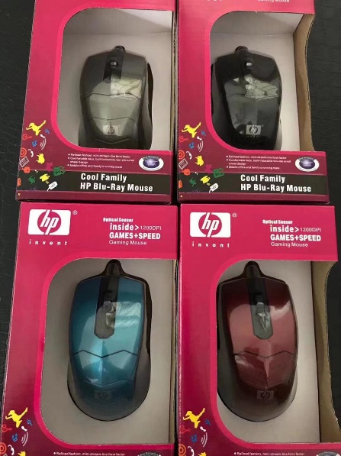



CHAPTER 4

SYSTEM DEVELOPMENT METHODOLOGY (SDLC)

PHASES OF SDLC

1. Feasibility study or planning
2. Analysis and specification
3. System design
4. Implementation
5. Maintainance /support

FEASIBILITY STUDY

Economic Feasibility:

1. Market analysis: Research the potential market for your product or service. Look at the size of the market, the competition, and the demographics of potential customers. Consider whether the market is growing, stable or declining.
2. Revenue potential: Determine the potential revenue your ecommerce store can generate. This can be estimated by the market size, pricing strategy, and average customer value.
3. Cost analysis: Consider the costs involved in setting up and running an ecommerce store, including website development, hosting, marketing, inventory management, and customer service. Estimate the total cost and break it down into fixed and variable costs.
4. Profitability: Analyze the potential profitability of the ecommerce store by comparing the revenue and costs. Consider different scenarios and the break-even point. Calculate the return on investment (ROI) and payback period.
5. Funding: Determine how much funding you will need to start and run the ecommerce store. Consider sources of funding, such as loans, grants, and investors.
6. Legal and regulatory requirements: Determine the legal and regulatory requirements for setting up and running an ecommerce store, such as business registration, taxes, data privacy, and consumer protection laws.
7. Risk analysis: Identify potential risks and challenges that could affect the success of the ecommerce store, such as changes in the market, technology, or competition.
8. Scalability: Determining the scalability of the ecommerce store, and whether it can be expanded to meet future growth.

TECHNICAL FEASIBILITY

#### Hardware requirements

|  |  |  |
| --- | --- | --- |
| **Description** | **quantity** | **Price (Kshs)** |
| Laptop computer with -  Celeron core2 duo processor  500 Gb HDD  3 Gb RAM | 1 | 50000 |
| Flash disk 8gb | 1 | 1600 |
| External backup disk(1TB) | 2 | 30000 |
| Transport expenses |  | 3000 |
| Research and Internet Costs |  | 2000 |
| Photocopying Costs |  | 2000 |
| Stationary |  | 1000 |
| **Total** |  | **87,600** |

#### Software Component System Requirement:

* Browsers: Microsoft Internet Explorer, Firefox, Chrome
* Server: Xampp
* Operating System: Windows XP, 7, 8, 10 and Linux.
* Back end: MySQL, PHP
* Front end: CSS, HTML, JavaScript.

STRUCTURED ANALYSIS

DATA DICTIONARY

Is a structured repository of data elements in the system.

It stores elements that is , details and definitions of data flows , data stored and processes.

Without a data dictionary, however, a database management system cannot access data from the database. Below are the illustrations:

The login table:

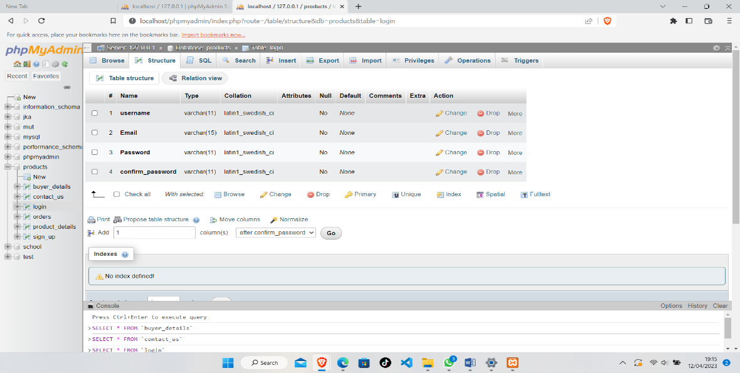

The product_details table:

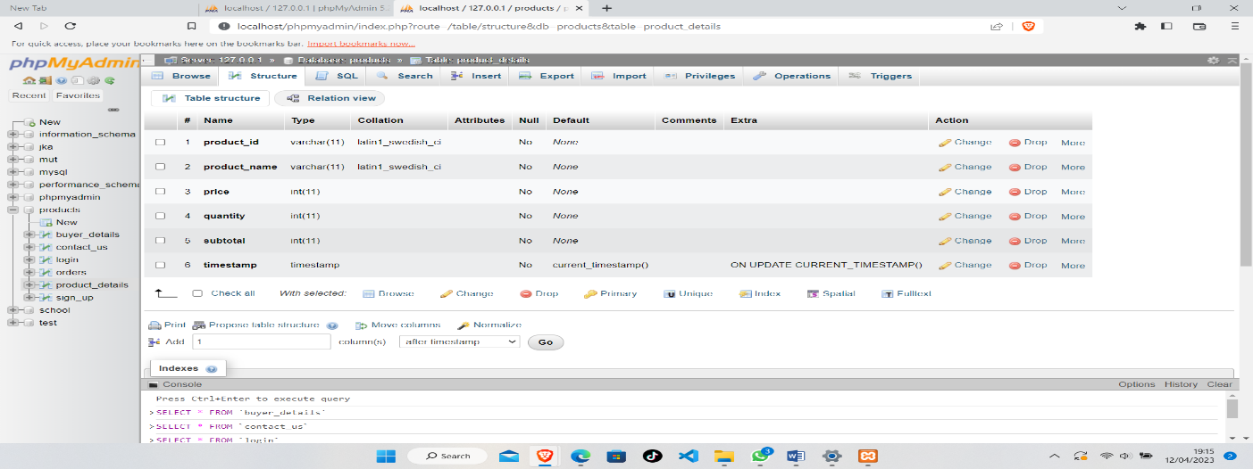

Buyer_details table:

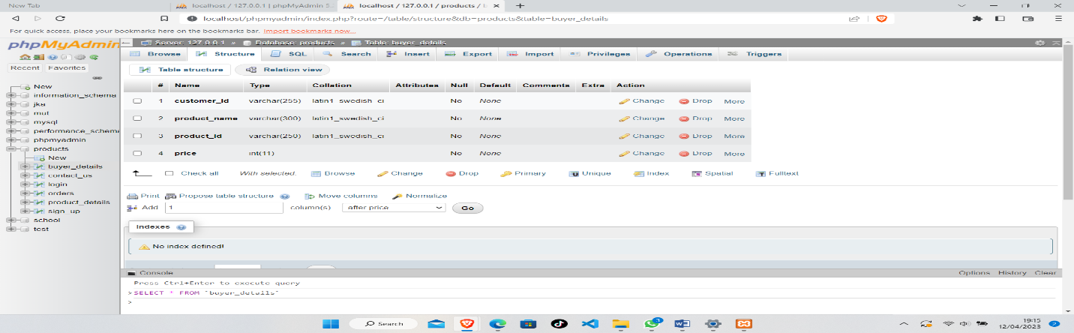

Orders table:

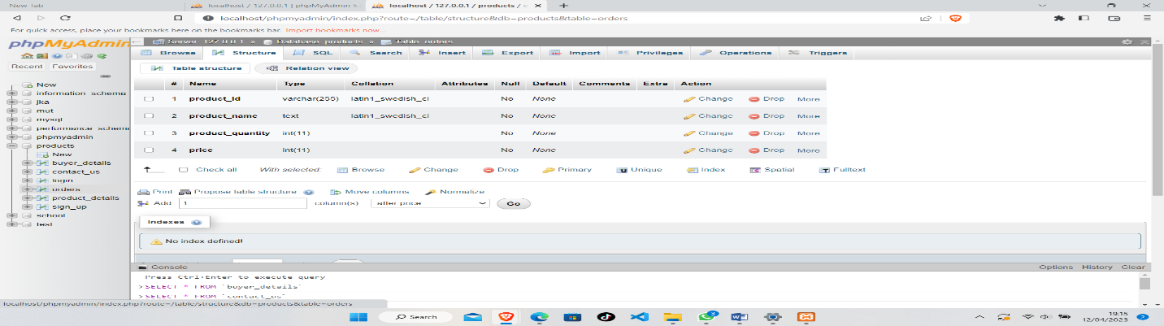

DATA FLOW DIAGRAM

Start

Login

Authorized?

Buy item

Stop

Register

No

Yes

Yes

Item successfully   
added to cart

View items

CHAPTER 5

SYSTEM IMPLEMENTATION (CODING AND TESTING)

INTRODUCTION

Testing is the process or activity that checks the functionality and correctness of software according to specified user requirements in order to improve the quality and reliability of system.

## Introduction

It is the processes of putting the proposed system in operation. Some of the Activities undertaken by the analyst are Training personnel who will use the system. There is also provision of user manual and help page for efficient use of the system.

Next is to install Computer Equipment and internet to help them connect with their clients in the globe. This will facilitate the full functionality of this proposed system. Equipment should be acquired from recognized vendor. These include central processing unit (CPU), Ethernet cables, routers, output and input devices e.g. keyboard, mouse, monitor and all secondary storage devices. The hardware and software vendors have major responsibility for installing these equipment. The analyst then determines the functional changes. E.g. may analyze the job function changes caused by the computerized system.

## Coding

Coding is the construction of the actual system using specific language. For this proposed system, I have used PHP to actualize the system. It is a scripting language, more secure and web based.

## Application and Database Connection

The constructed system is connected to the MYSQL Database through a data environment. The tables were created and normalized. The data is also well validated. A connection is also set and established in the design of the respective forms.

## Testing

Testing is the process of verifying and validating the system for the conformance with specification and meeting the customer’s requirements. The objectives of testing are to ensure that the system programs is error free, guarantee the system end users can interact with the system well and ensure that the components of the system interface are working well.

### Functional Testing

The purpose of functional testing is to ensure that the program performs all the functions that were originally specified, that all the input is correctly accepted. It relates to the whole system and does not require a technical understanding of the system. All the functions of the system as originally specified are systematically tested to ensure that nothing has been accidentally omitted or misinterpreted. A positive attempt is made to anticipate errors than an inexperienced user might make, and tests made to check the effect of such errors and ensure that they do not result in incorrect actions or bad data being stored in the database.

### System Testing

This is where the system is checked whether it has met the user requirements and performs as per expectations. The following are the tests to be used. On completion of the whole system, each of it is tested to ensure no errors have been introduced. The system is tested with a realistic amount of test data; although the researcher is not expected to spend days typing in hundreds of records, the system should be tested with about 50 records in each of the main tables.

#### Recovery Testing:

Recovery testing can be carried out to determine what happens, for example if there is a power failure in the middle of data entry. Is the whole database corrupted?

#### Acceptance Testing

The user is invited to test the system to ensure that it fulfills the stated objectives. If possible the researcher should observe this testing and not stop the user from mistakes. The system should cope with unexpected user behavior.

#### User Acceptance testing

This is testing of the system by the user department after the system has passed the systems test

### Unit testing

After the parts of the system are completed they are first tested. All the new hardware, procedural manuals and all system interfaces must be tested to ensure that they meet the required standards.

## Test Data

The purpose of test data is to verify and make sure that the system is operating well and according to the standards set. It involves checking the new system if it is working correctly. It is tested in modules to establish if there is any problem in any module. This is whereby each module is tested on its own. While testing entries should be inputted as they are so as to be acceptable in the database else errors will occur. As an example, if customer’s Id should be in numbers so the field should not accept text.

## File Conversion

The analyst changes the existing files into a form where it can be used by the new system. The procedure is as follows; the analyst first record the file data then Transcribe the documents to suitable media and Verifies data to ensure it is error free

## Control

Control measures to be put in place for the system is; Password where the user is required to enter his/her password to log in. It is only to authorize users.

The antivirus software should be used to clean up the viruses harmful to the application. Physical security such as keeping the system in a safe room- Ensure that there are firm windows and Doors and guarding the place.

**Physical Design:**

**the login form:**

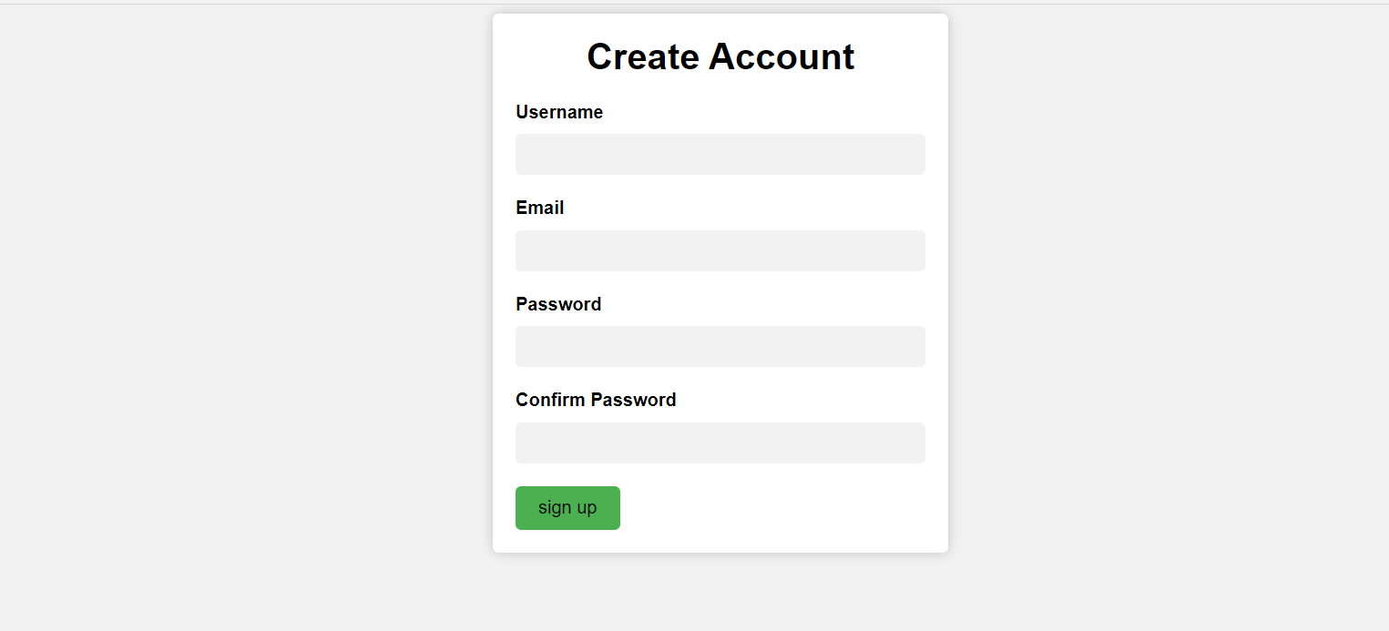

**The home page interface:**

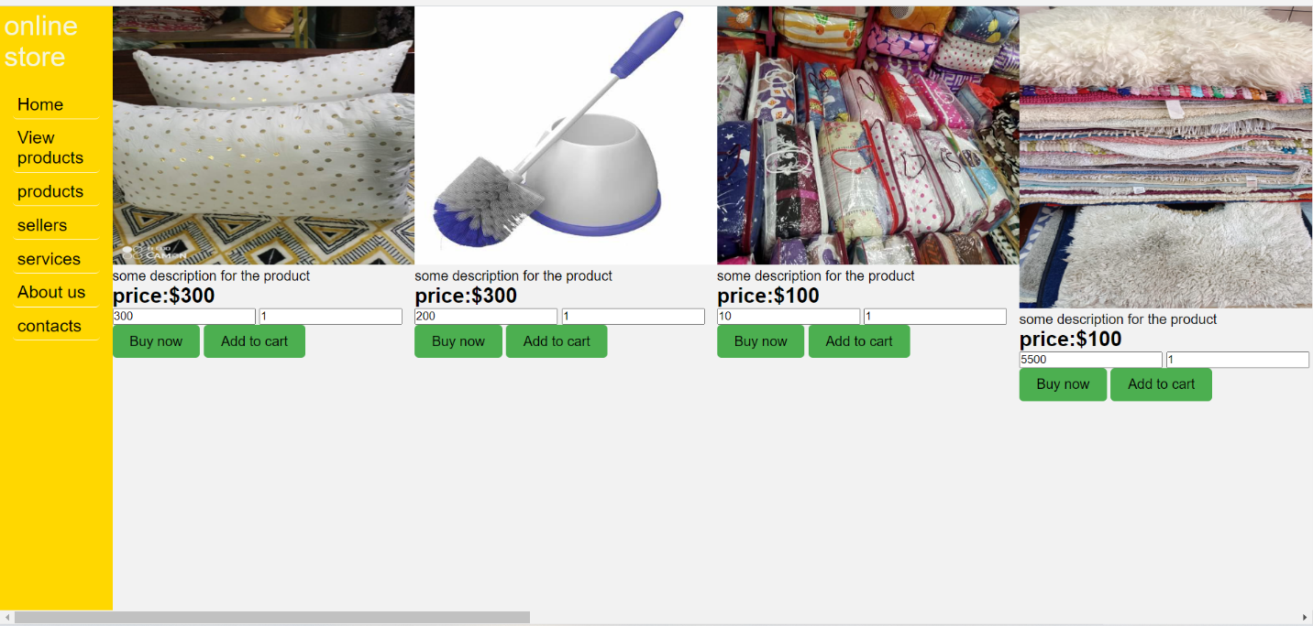

**Admins view of product details:**

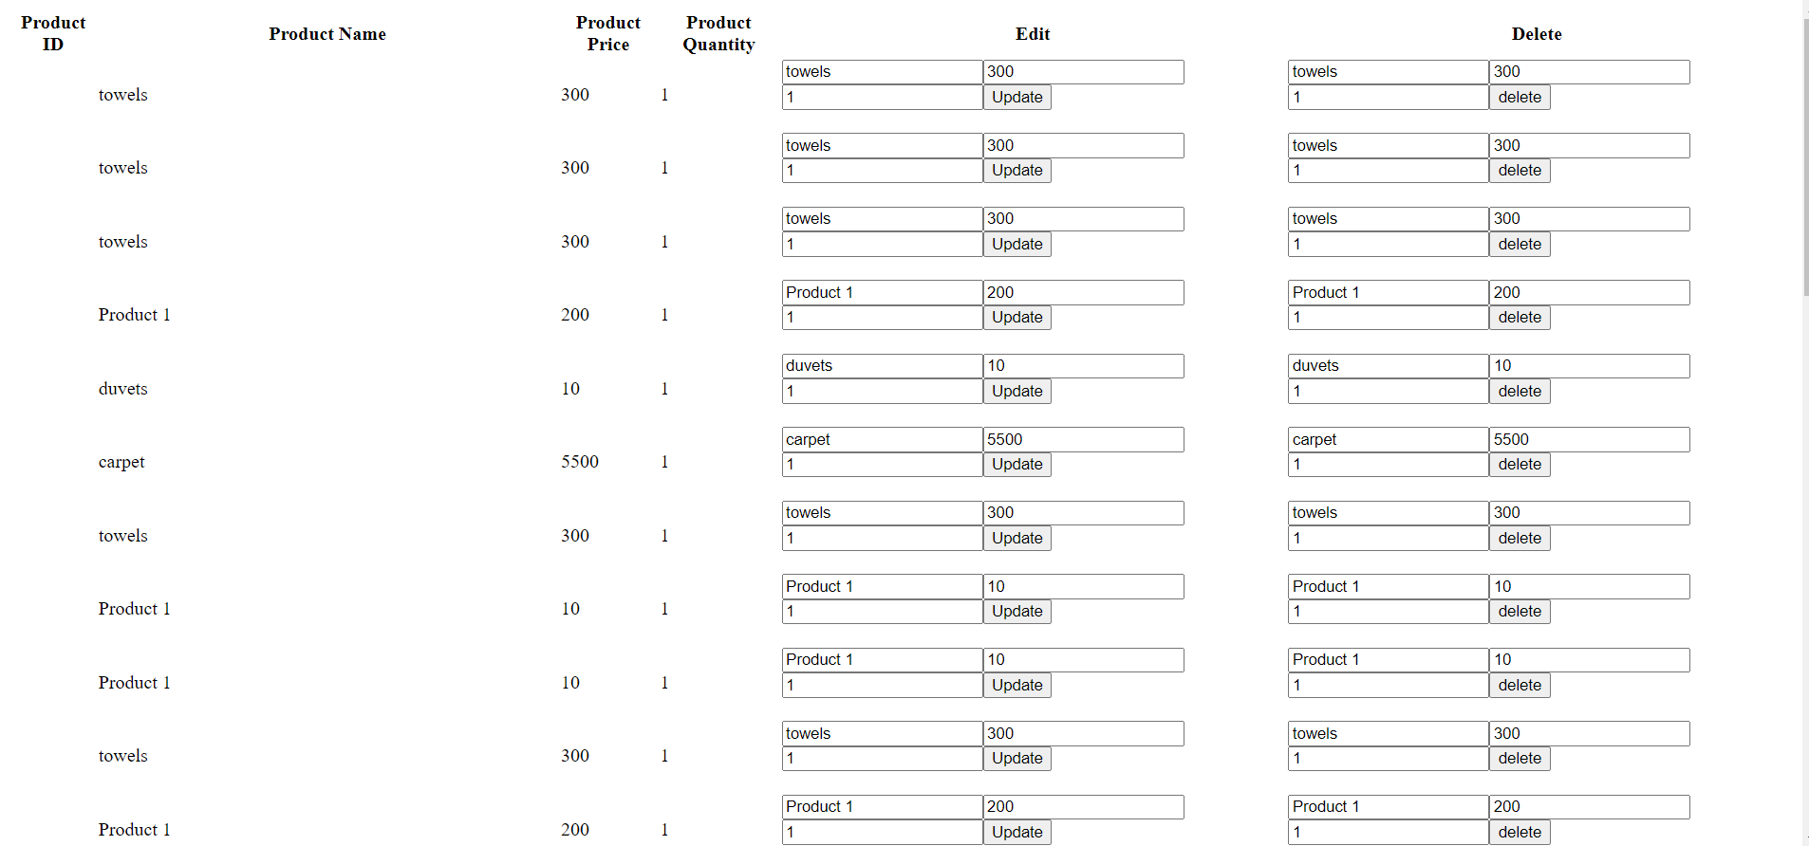

**Admins view of user’s who have an account:**

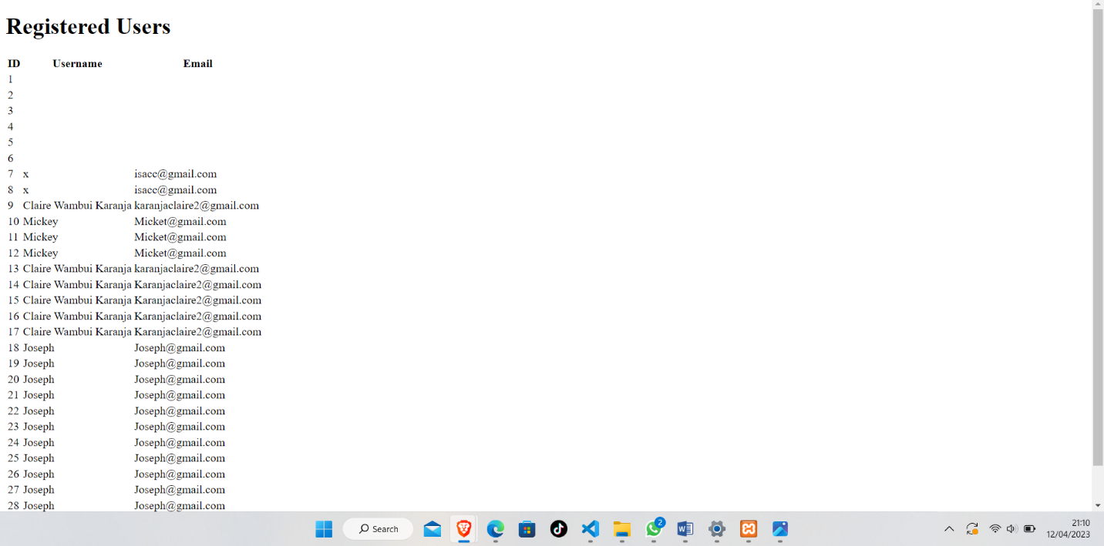

**CHAPTER SIX : SUMMARY, LIMITATIONS , CONCLUSIONS AND RECOMMENDATIONS**

This chapter describes the objectives of the system stipulated in earlier chapter, limitation of the system, conclusion and recommendation of the system.

Summary:

As discussed in the above chapters the system is a local online store that provides ecommerce services to the students of Murang’a university this will help both the students and sellers to connect with each other. The students won’t find the need to keep on searching for products everywhere and the vendors won’t find the need to go around marketing their products in every hostel that has students.

Limitations

The limitations of the above product is that users might not find what they are looking for in the stores. Inadequate funds to actually get the system to be implemented. Some store owners refuse their products to be marketed online. The project was kind of complex as at it is also supposed to include electronics .

Conclusions:

The above project is would be good for both students and the vendors . It is a new way of doing shopping as compared to the one we are already used to as students you know going out and going from store to store comparing prices and quality .

RECOMMENDATIONS:

That an admin of the above system should take into consideration factors like will the user share their feedback whether they are being satisfied by the service offerded by the the system. Any change in prices should be registered by the system such as drop in price or raise . A new product in the market should also be added to the system which is the work of the admin.

REFERENCES:

[1] History of online shopping- Dr . M Edwin Gnanadhas Ph.D

[2] online shopping information system- Wikipedia

[3]Admin’s point of view- carmen Ang

APPENDIX: SAMPLE CODES

<?php

// Retrieve form data

$username = $_POST['username'];

$email = $_POST['email'];

$password = $_POST['password'];

$confirm_password = $_POST['confirm_password'];

// Validate form data

if(empty($username) || empty($email) || empty($password) || empty($confirm_password)) {

    // One or more fields are empty

    echo "Please fill in all fields.";

    exit;

}

if($password !== $confirm_password) {

    // Passwords do not match

    echo "Passwords do not match.";

    exit;

}

// Connect to database (replace the placeholders with your actual database credentials)

$dbserver="localhost";

$dbusername="root";

$dbpassword="";

$dbname="products";

$con=mysqli_connect($dbserver, $dbusername, $dbpassword, $dbname);

if(!$con)

{

    die("db connection failed" . mysqli_connect_error());

}

// Insert user data into the database

$sql = "INSERT INTO sign_up (username, email, password) VALUES ('$username', '$email', '$password')";

if (mysqli_query($con, $sql)) {

    echo  "Account created successfully.";

} else {

    echo "Error: " . $sql . "<br>" . mysqli_error($con);

}

// Close database connection

mysqli_close($con);

?>